Anti-Repost Tool for Cosplay Photos: Design Plan
Edition 1 (Draft) 2026-09-29 · Ishikawa Sou (石川宗)
Nagareyama Software Development Co., Ltd. (NRSD)
© 2026 Nagareyama Software Development Co., Ltd. (NRSD), Lead Developer: Ishikawa Sou (石川宗) Copyright in this Design Plan and in the software developed under this Design Plan belongs to Nagareyama Software Development Co., Ltd. (NRSD). However, rights in the third-party standards, algorithms, and software considered for adoption in this Design Plan belong to their respective rights holders (see Chapter 17).
Contents
Revision History
Chapter 1 Position of This Document
Chapter 2 Purpose and Scope
Chapter 3 Parties and Users
Chapter 4 Overview of the System
Chapter 5 Authentication of Users
Chapter 6 Platform and Development Base
Chapter 7 Forms of Photographs and Processing Streams
Chapter 8 Screens and Usability
Chapter 9 Rights Documents and Languages
Chapter 10 Registration of Reposts, Evidence Preservation, and Status Checking
Chapter 11 Scope of Support for Legal Action
Chapter 12 Repository Management, Distribution, and Updates
Chapter 13 Treatment of Phase 2
Chapter 14 Matters To Be Investigated
Chapter 15 Open Matters
Chapter 16 Comparison with the Draft Project Proposal
Chapter 17 Third-Party Rights and Licenses
Chapter 18 References

Revision History
Edition | Date | Description | Author
Edition 1 (Draft) | 2026-09-29 | Newly created, with the Draft Project Proposal (2026-09-24) as the initiating document | Ishikawa Sou

Chapter 1 Position of This Document

1.1 Purpose of This Document
This document defines, for the “Anti-Repost Tool for Cosplay Photos” (hereinafter the “System”), what is needed in order to build the System, before the design document is written.
This document lays out, item by item, and settles who the users are, how and when the users use the System, on which platforms it runs, what serves as the development base, and how publication, distribution, and operation are managed.
This document does not specify how the System is to be realized. The means of realization are left to the design document; this document clarifies the matters that the design document shall take as premises and the matters that shall be investigated in detail at the design document stage.

1.2 Document Structure
The Draft Project Proposal sets out the document structure of the System as follows.
This draft proposal is the initiating document for the design plan, and the documentation is organized in the following order. Draft project proposal (this document): concept and basic policy / Design plan: turns this draft proposal into concrete terms and confirms the development scope and actions / Design document: overall system architecture and approach / Detailed design document: implementation specifications for each function
（Draft Project Proposal, Section 13）
This document is the “design plan” in this structure. Figure 1 shows the relationship between this document and the other documents.
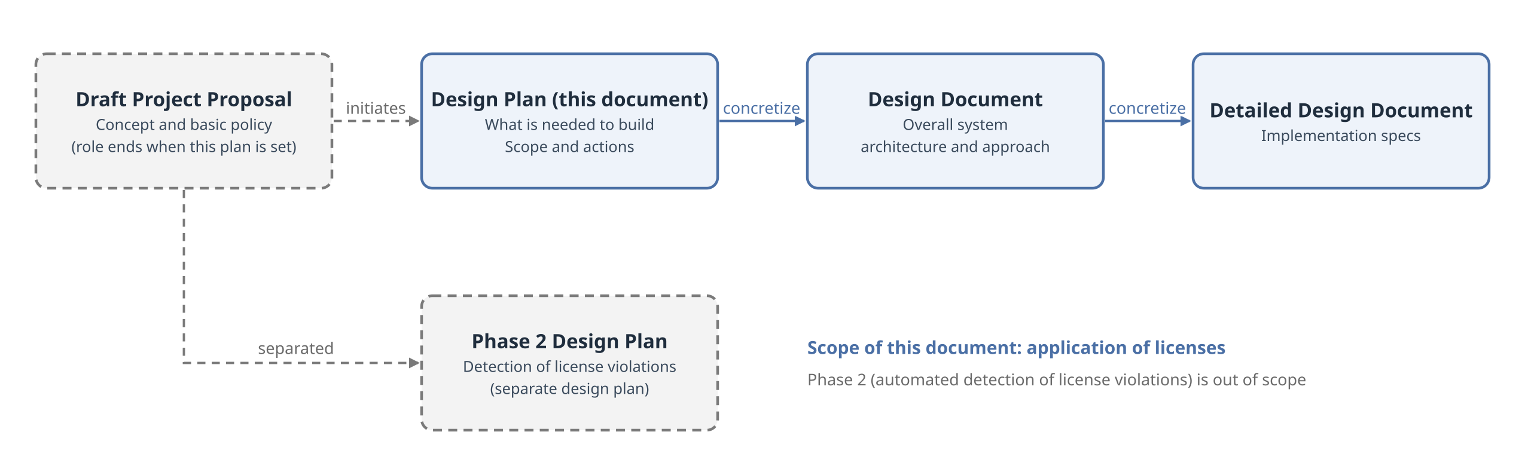
Figure 1 Document structure
The automated detection application described in Section 12 of the Draft Project Proposal as Phase 2 of the System is treated as a design plan separate from this document (see Chapter 13).

1.3 Relationship with the Draft Project Proposal
The Draft Project Proposal is the document that prompted the drafting of this document. Upon the establishment of this document, the Draft Project Proposal has fulfilled its role, and its force shall be subordinate to this document.
Where the Draft Project Proposal and this document differ, this document prevails. How each section of the Draft Project Proposal is treated in this document is shown in the comparison table in Chapter 16.
When this document quotes the Draft Project Proposal, it indicates that it is a quotation and states the section quoted.

1.4 Classification of Statements
This document classifies each matter as follows.
Class | Meaning
Decided | A matter settled in this document. The design document shall take it as a premise
[Design Required] | A matter for which only the requirement is set in this document and whose means of realization the design document must set. No countermeasure exists at present
To Be Investigated | A matter for which facts shall be investigated at the design document stage, with the means of realization set according to the results (listed in Chapter 14)
Open | A matter whose conclusion is reserved at the stage of this document, or a candidate whose adoption has not been decided (listed in Chapter 15)
Deferred to Design Document | A matter whose existence alone is confirmed at the planning stage, with its content set in the design document

Decisions in each chapter are numbered in the form “D-chapter-sequence” so that they can be referenced from the design document.

1.5 Definitions
The terms used in this document have the following meanings.
Term | Meaning
System | The whole system covered by this document, consisting of the Client App, the Public Repository, and the Private Repository
Client App | The software of the System that runs on the User’s device
Rights Holders | The authors and subjects of the photographs (as defined in Section 1 of the Draft Project Proposal)
Users | Those who use the System: the Rights Holders, or those authorized by either of them (defined in Chapter 3)
Signer | A person who holds a signing key and signs images with the Client App
Original | Photo data held by the Rights Holder before publication (including RAW, unprocessed data, and unpublished photographs)
Matching Data | Information attached to an image for matching against the Original, including the C2PA signature (manifest), the invisible watermark, and the identification number
Matching hashes | Perceptual hashes and image features. They are not attached to the image but recorded for matching (the recording location is Open; O-10)
Identification number | A number issued for each work and recorded in both the C2PA manifest and the file name (per Section 4 of the Draft Project Proposal)
Delivery Image | An image delivered to a purchaser through a sale
Social Media Image | An image posted to a posting site for the purpose of sales. A Visible Signature is added
Visible Signature | A mark placed visibly on an image, such as the Rights Holder’s name, account name, date, overlay image, license statement, or other display
Permitted Scope | The scope of use that the Rights Holder licenses to purchasers for Delivery Images
Rights Document | A document stating the Permitted Scope and provisions concerning rights
Enclosed Document | A Rights Document or other document enclosed with Delivery Images
Notice | The Rights Holder’s policy on unauthorized reposting, posted on every site where works are posted (per Section 3 of the Draft Project Proposal)
Reposter | A person who reposts images against the Rights Holder’s intent
Infringer | A person who has published images without the Rights Holder’s permission, or has used images beyond the Permitted Scope, and has caused damage to the Rights Holder, regardless of whether the person is a purchaser
Registration | The recording in the System, from the Client App, of a repost found by a User (corresponding to “reporting” in the Draft Project Proposal)
Rights Holder Information | Information showing who the Rights Holder is. It is the key to preventing impersonation
Evidence Preservation | Leaving, at the time of Registration, a record to be used for later action
Public Repository | The GitHub repository in which the software of the System is published
Private Repository | The non-public GitHub repository in which the information that the System must protect is placed

Chapter 2 Purpose and Scope

2.1 Purpose
The Draft Project Proposal sets out the purpose of the System as follows.
The purpose of this proposal is to enable authors and subjects of cosplay photographs (hereinafter the “Rights Holders”) to detect, prove, and take legal action against reposting made against the author’s intent and other unlawful reposting, with minimal burden.
（Draft Project Proposal, Section 1）
This document inherits this purpose and sets out what the System seeks to protect as follows.
- What the System protects shall be the rights (copyright and portrait rights) that the Rights Holders have in their own photographs.
- The System shall protect those rights through the application of licenses, that is, by putting the Rights Holders in a position to display rights on their photographs, set a Permitted Scope, and assert their rights against use beyond that scope.
The software of the System itself (source code and binaries) is not something the System protects. Even if the software is copied or taken away, the rights of the Rights Holders are not harmed. The rights of the Rights Holders are harmed when someone impersonates a Rights Holder, or when Rights Holder Information or other records are tampered with, and the System is required to prevent these (see Chapters 5 and 12).

2.2 Basic Policy
The Draft Project Proposal sets out the basic policy of the System as “detection, proof, and deterrence.”
At present, it is difficult to technically stop reposts made against the author’s intent, or other unlawful reposting, in themselves. As a preliminary step toward that end, this system is intended for detection, proof, and deterrence.
（Draft Project Proposal, Section 2）
This document positions deterrence among these as the greatest value of the System. It is considered that showing that the Rights Holder displays rights, states the Permitted Scope, and has the intent and the means to take action when appropriate has the effect of dissuading reposting even before any action is actually taken.
If an actual action does not succeed, it shall be treated as an issue and carried into the next improvement, and matters requiring legal judgment shall be referred to experts (see Chapter 11).

2.3 Scope of This Document
The scope of this document is the application of licenses. Specifically, the following matters are within scope.
- Authentication of Users (Chapter 5)
- Signing of images, attachment of Matching Data, and addition of Visible Signatures (Chapter 7)
- The image editing screen, batch application, and the Rights Document creation screen (Chapter 8)
- Selection of the Permitted Scope and generation of Enclosed Documents (Chapter 9)
- Registration of reposts by Users themselves, Evidence Preservation, and status checking (Chapter 10)
- Guidance on legal action (Chapter 11)
- Repository management, distribution, and updates (Chapter 12)
Figure 2 shows the scope of the System.
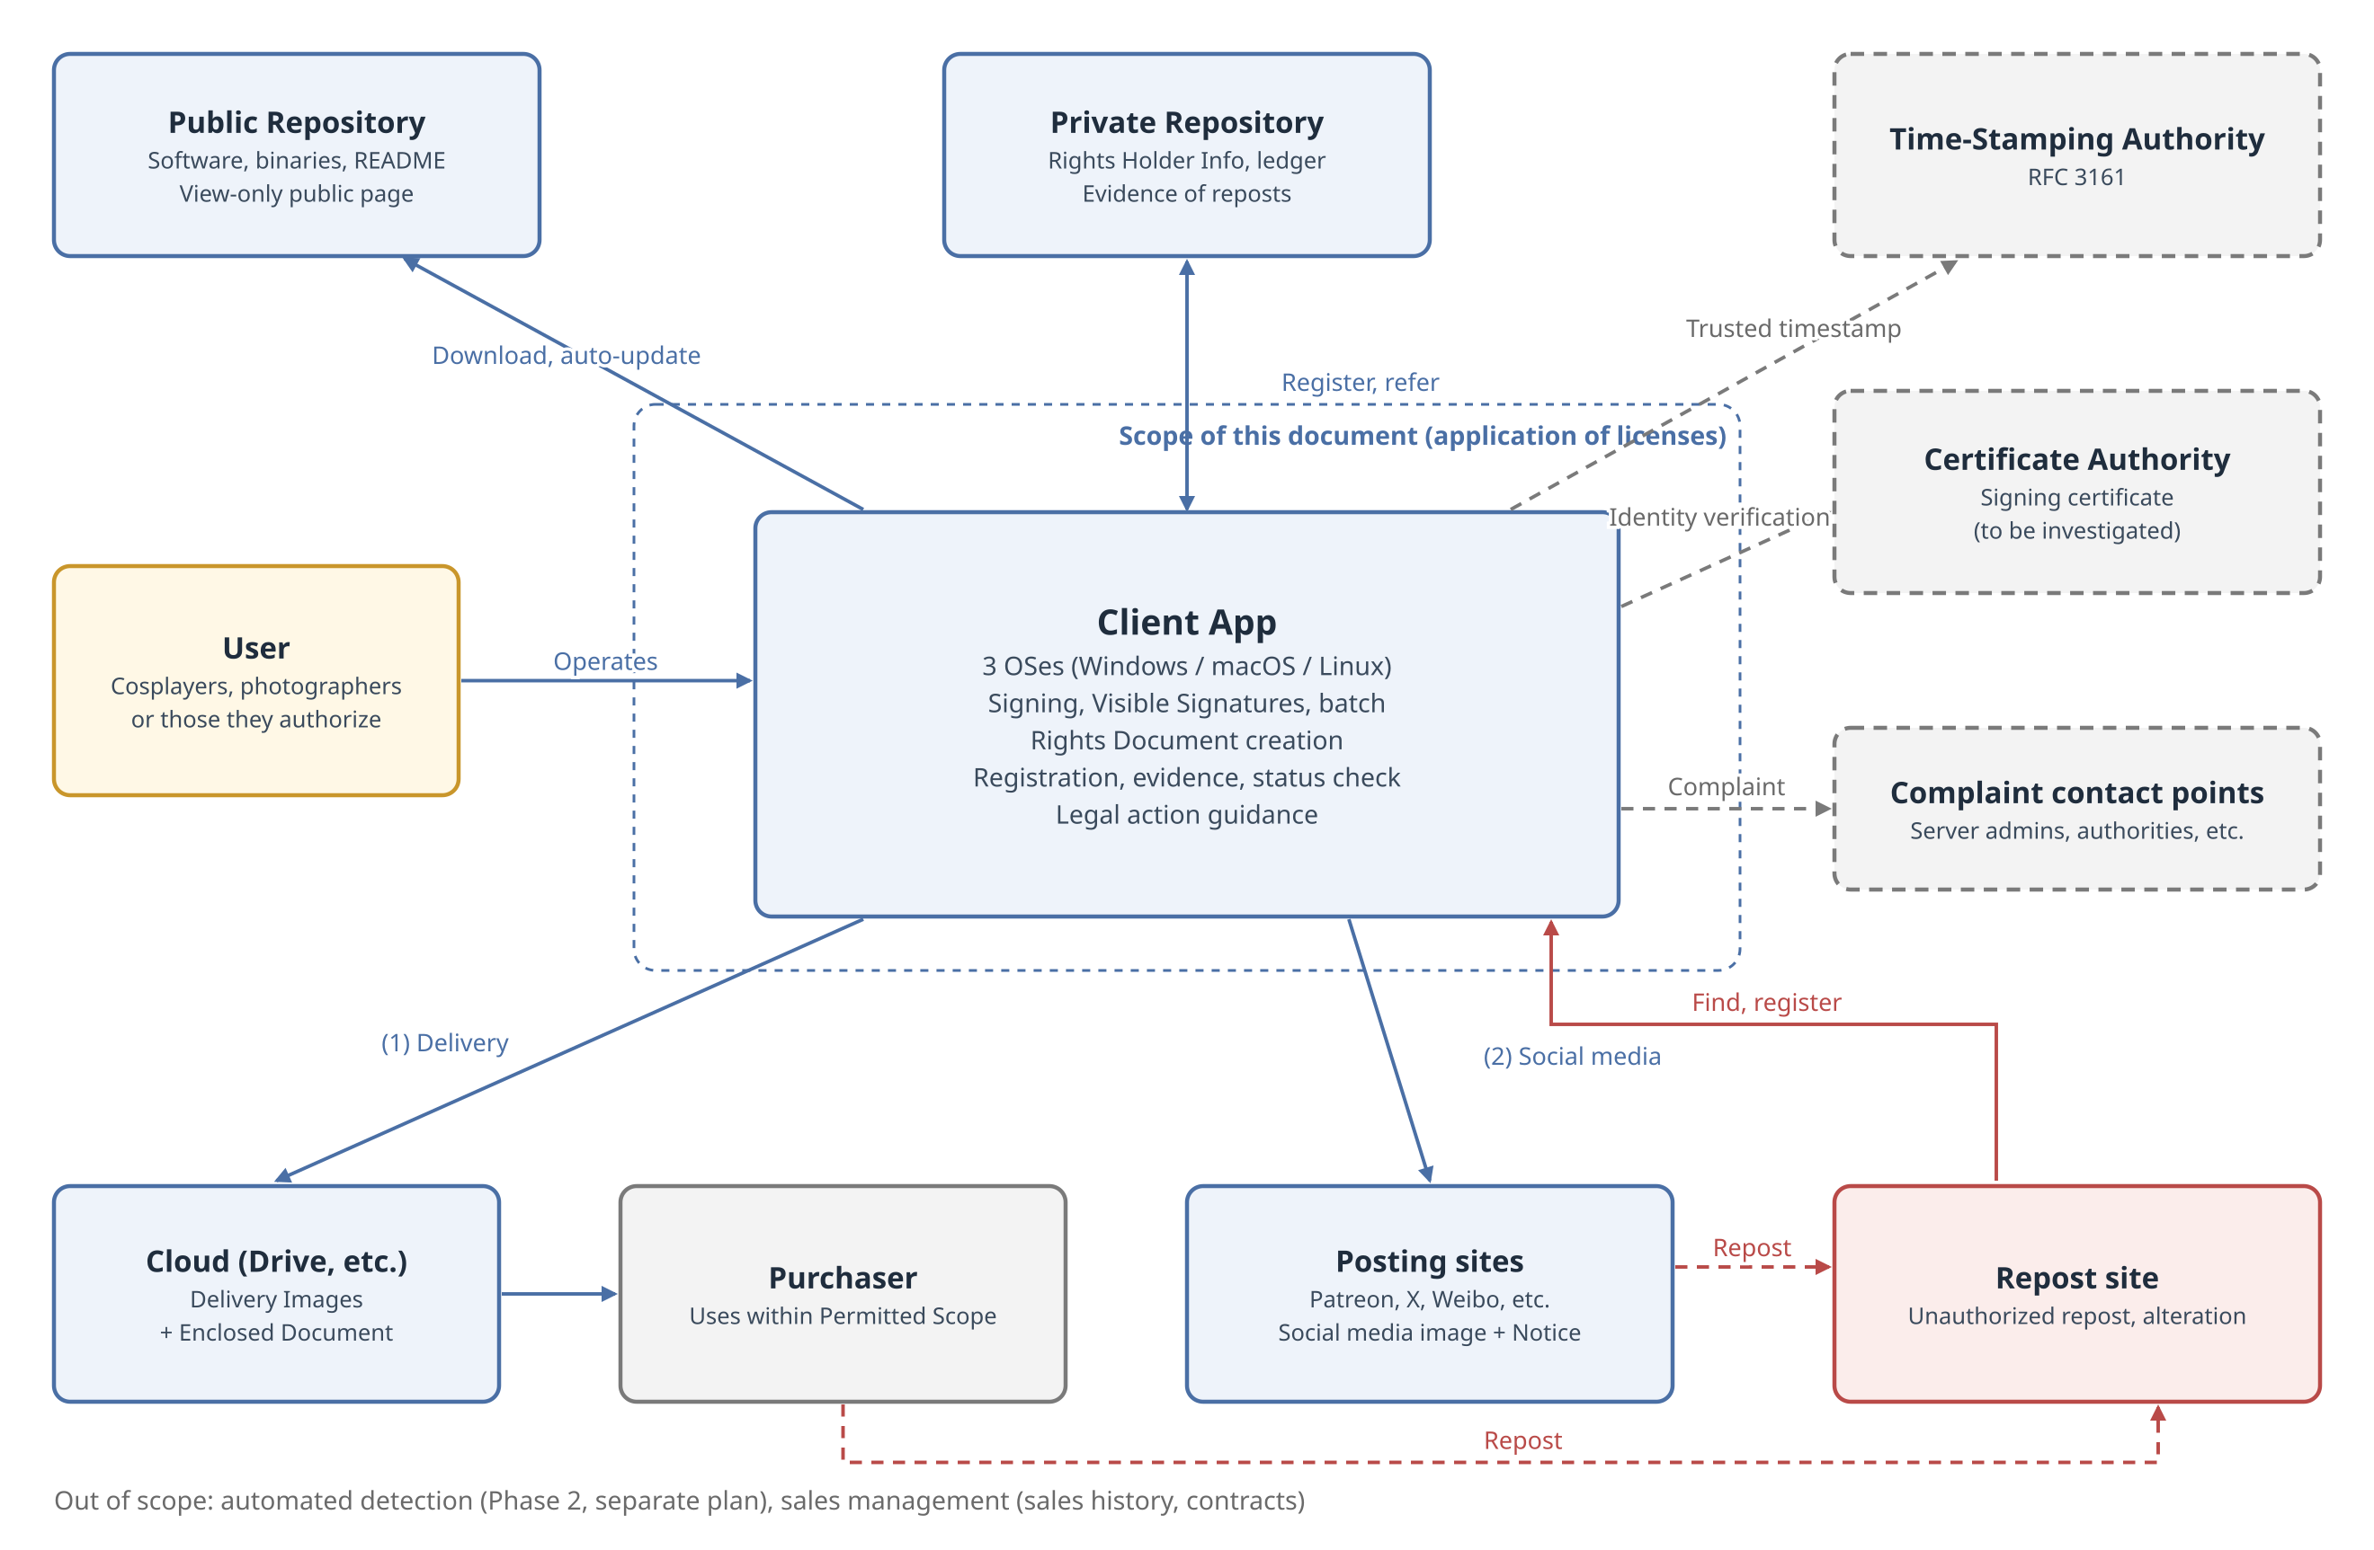
Figure 2 Scope of the System

2.4 Out of Scope
The following matters are outside the scope of this document.
Out-of-scope matter | Reason | Treatment
Automated detection (crawling the network and automatically detecting reposts) | It lies on a different axis from the application of licenses and corresponds to the detection of license violations | Treated as a separate design plan (Chapter 13)
Sales management (management of sales history, sales contracts, and purchaser information) | The purpose of the System is to stop rights infringement, not to manage sales | Not handled. Anyone who needs it shall fork the Public Repository and modify it; NRSD takes no part in the results
Representation in lawsuits or other legal proceedings, and legal judgment | The System is not a substitute for legal experts | Not performed. Limited to presenting contact points (Chapter 11)
Identification of purchasers | As set out in Chapter 9, the party pursued is the Infringer, regardless of whether it is a purchaser | Not performed

2.5 Limitations Carried Over from the Draft Project Proposal
The following limitation stated in Section 10 of the Draft Project Proposal is carried over into this document.
This system does not eliminate unauthorized reposting itself, and its effect is limited to photographs posted after the tools are introduced.
（Draft Project Proposal, Section 10）
- Photographs published before introduction carry no signature or Matching Data. For these photographs, rights shall be shown through preservation of the Original and work registration (per Section 10 of the Draft Project Proposal).
- Photographs published before introduction may become targets of the impersonation described in Chapter 5.

2.6 Decisions in This Chapter
No. | Decision
D-2-1 | What the System protects shall be the rights (copyright and portrait rights) that the Rights Holders have in their own photographs
D-2-2 | The scope of the System shall be the application of licenses
D-2-3 | The greatest value of the System shall be deterrence
D-2-4 | Automated detection shall be a separate design plan
D-2-5 | Sales management is not handled. Anyone who needs it shall fork and modify the System, and NRSD takes no part in the results
D-2-6 | Representation in legal proceedings and legal judgment are not performed

Chapter 3 Parties and Users

3.1 Parties
The persons related to the System, organized by type of person, fall into the following five types.
Type | Relationship with the System | Inside or outside the System
Cosplayer (subject) | Holds portrait rights. Sells and posts photographs | Inside (User)
Photographer | Holds copyright (ownership may differ depending on the agreement with the cosplayer) | Inside (User)
Reposter | Reposts images against the Rights Holder’s intent. A person who reposts with the Rights Holder’s authorization is not a Reposter and is treated as standing on the Rights Holder’s side | Outside
Viewer | Recognizes, on posting sites, whether a photograph is genuine through the caption and the Notice. Signature verification is performed on existing public verification sites [15] | Outside
Operator (NRSD, fork operators) | Builds the System and, by design, always exists | Not defined within the System

In addition, posting sites, operators of repost sites, hosting providers, time-stamping authorities, certificate authorities, courts, complaint contact points, and other organizations are involved; these are not persons and are treated as organizations outside the System.

3.2 Definition of Users
The Users of the System shall be the Rights Holders of the images and those authorized by either of them. That is, a User shall be a cosplayer, a photographer, or a person authorized by either of them.
This definition is derived from the following reasoning.
- Viewers achieve their purpose through posting sites and existing public verification sites without using the System, and are therefore outside the System.
- The Operator is the maker of the System and need not be defined within the System.
- Those who repost without authorization do not use the System. Those who are authorized stand on the side of the cosplayer or the photographer.
- Therefore, those who use the System are limited to the Rights Holders of the images and those authorized by them.

3.3 Profile of Users
Users are treated as having the following characteristics.
- Users are not engineers. The System shall not presuppose an understanding of GitHub, and Users shall be able to use the System without looking at GitHub.
- Users exist across countries. In addition to Japan, China, and English-speaking regions, Users living in countries such as Canada are also assumed.
- Users like characters and cute things. Software that looks unappealing will not be used (see Chapter 8).
- Users post to social media in order to sell photographs, and deliver sold photographs to purchasers by sharing through the cloud (Google Drive, etc.).

3.3.1 Example of a User
The example of one User (a cosplayer living in Canada), confirmed by NRSD in September 2026, is as follows. This is one example of the profile of Users and is one of the grounds for each chapter of this document.
- The User is active in English on a support service (Patreon).
- On posted images, the User places, in handwriting-style lettering, the account name and the locations of the support services (including a support service for China) as a Visible Signature.
- The Visible Signature is placed in the background area where it does not overlap the subject, and its position, orientation (horizontal, or vertical rotated 90 degrees), and color (white or black depending on the background) are adjusted for each photograph.
- Adjusting the Visible Signature one image at a time requires effort.
- The User delivers full-size images to supporters by sharing through the cloud (Google Drive).

3.4 Premises
The following matters are treated as premises, without conducting interviews, in building the System.
- The actual delivery (route, format, and size), the actual Visible Signatures, and the rights relationship with the photographer are all treated as being understood by the cosplayer personally.
- If there are deficiencies in the premises, they shall be improved after Users have become able to use the System, upon receiving comments from Users. Conducting interviews while the System cannot be used would not convey to Users what the discussion is about.

3.5 Unintended Parties
In addition to those listed in Section 3.1, a person who poses as the Rights Holder may enter the System. The Draft Project Proposal describes no countermeasure against such a person. This document treats this as [Design Required] in Chapter 5.

3.6 Decisions in This Chapter
No. | Decision
D-3-1 | The Users shall be the Rights Holders of the images (cosplayers and photographers) and those authorized by either of them
D-3-2 | Viewers and the Operator are not defined within the System
D-3-3 | Users shall be able to use the System without looking at GitHub
D-3-4 | The System is built on the premise that delivery, Visible Signatures, and the rights relationship with the photographer are understood by the cosplayer personally
D-3-5 | No interviews are conducted; improvement is made based on comments after the System becomes usable
D-3-6 | [Design Required] A person posing as the Rights Holder shall not be able to enter the System (Chapter 5)

Chapter 4 Overview of the System

4.1 Components
The System consists of the following elements.
Component | Role
Client App | Runs on the User’s device and performs signing, Visible Signatures, batch application, creation of Rights Documents, Registration, Evidence Preservation, status checking, and guidance on legal action
Public Repository | Holds the source code, binaries, the README, and the view-only public page
Private Repository | Holds Rights Holder Information, the ledger, and evidence of reposts
External organizations | Time-stamping authorities, certificate authorities, posting sites, the cloud, complaint contact points, etc. The System uses them or guides Users to them

4.2 System Blocks
Figure 3 shows the inside of the Client App, divided into groups of functions (blocks). Figure 3 shows the configuration as far as can be conceived at the stage of this document; the approach for each block is set in the design document.
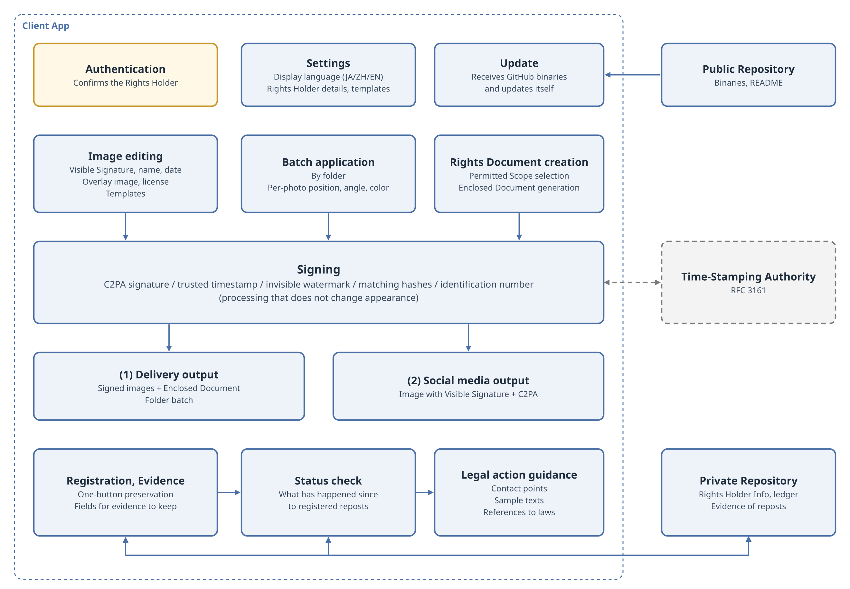
Figure 3 System blocks
Block | Function | Related chapter
Authentication | Confirms that the User is the Rights Holder personally | Chapter 5
Settings | Manages the display language, Rights Holder details, and templates | Chapters 8, 9
Update | Receives binaries from the Public Repository and updates the Client App | Chapter 12
Image editing | Creates and applies Visible Signatures, names, dates, overlay images, and license statements as templates | Chapter 8
Batch application | Processes by folder and adjusts placement, orientation, and color for each photograph | Chapter 8
Rights Document creation | Selects the Permitted Scope and generates Enclosed Documents | Chapter 9
Signing | Attaches or records C2PA signatures, trusted timestamps, invisible watermarks, matching hashes, and identification numbers | Chapter 7
Delivery output | Outputs signed images together with Enclosed Documents as a folder batch | Chapters 7, 9
Social media output | Outputs images with a Visible Signature, with a C2PA signature attached | Chapter 7
Registration and Evidence Preservation | Registers found reposts and preserves evidence | Chapter 10
Status check | Shows what has since happened to registered reposts | Chapter 10
Legal action guidance | Shows contact points, sample texts, and references to the laws of each country | Chapter 11

4.3 Usage Scenes
The scenes in which Users use the Client App are as follows.
Scene | User task | Timing
Preparation | Authenticate and prepare a Visible Signature template | Initially, and whenever changed
Notice | Post the Notice on every site where works are posted (per Section 3 of the Draft Project Proposal) | Once per site, initially
Sale | Batch-process the folder for delivery and upload it to the cloud together with the Enclosed Documents | Each sale
Posting | Create Social Media Images and post them to posting sites | Each posting
Registration | Register a repost from the Client App when found | When a repost is found
Check | Check the status of registered reposts | At any time
Action | Following the guidance, the Rights Holder personally files complaints or takes other action | At the Rights Holder’s discretion

Section 5 of the Draft Project Proposal provides that immediate action is not required upon confirming a repost. This document carries this over.
Immediate action is not required upon confirming a repost. Reporting preserves the evidence, and action may be taken collectively at a later date.
（Draft Project Proposal, Section 5）

Chapter 5 Authentication of Users

5.1 Requirement
The System shall be usable only by Users (the Rights Holders and those authorized by them). Issuing a C2PA signature requires authentication of the person who signs. Therefore, for a User to obtain the Client App and use it to issue signatures, the User must go through authentication for C2PA signing.

5.2 Misuse by Unintended Parties [Design Required]
Anyone can obtain the Client App from the Public Repository (see Chapter 12). Therefore, a person who possesses the Client App and also possesses another person’s photographs can misuse the System through the following steps. Figure 4 shows the flow of this misuse.
- The person obtains photographs that the Rights Holder has not yet signed (photographs published before introduction, leaked Originals, etc.).
- The person signs those photographs with the Client App before the Rights Holder does. This allows the person to pose as the “Rights Holder of the Original,” complete with a trusted timestamp.
- Further, using the Registration function, the person can register the true Rights Holder as a Reposter.
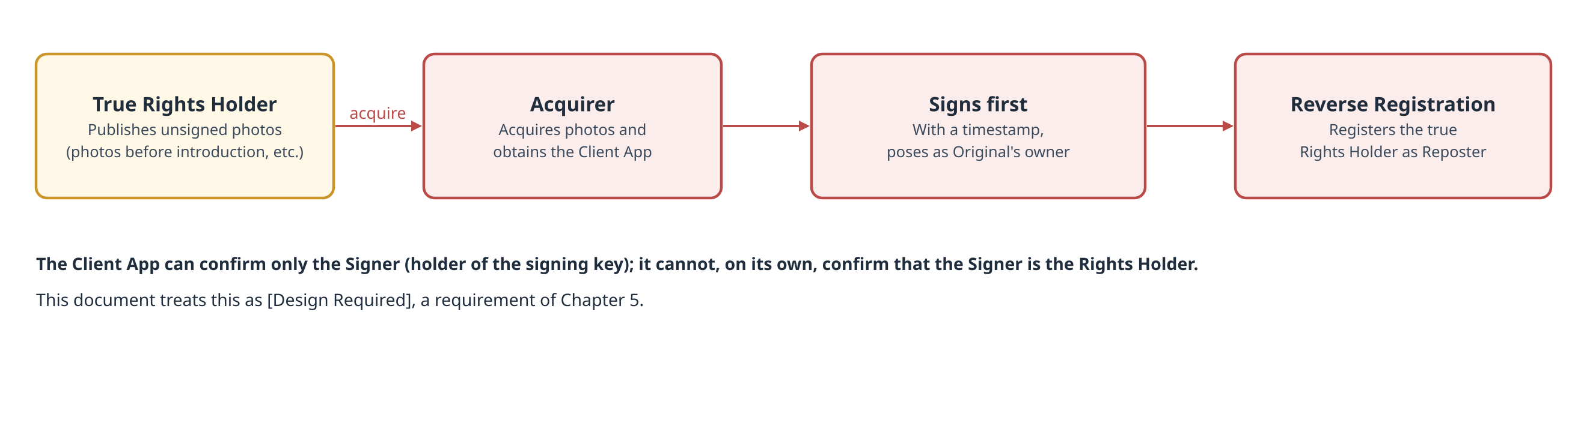
Figure 4 Misuse by a person posing as the Rights Holder
A mechanism meant to protect rights may become a tool for falsifying rights. This document treats this as [Design Required], and the design document must set countermeasures.

5.3 Identity and Entitlement
In dealing with this problem, this document distinguishes the matters to be confirmed into the following two.
Distinction | Matter to be confirmed | Candidate means of confirmation
Identity | Who signed | A signing certificate issued after identity verification by a certificate authority
Entitlement | Whether the person who signed is the Rights Holder of the photograph (or a person authorized by the Rights Holder) | Posting the signing key fingerprint or similar on the Notice accounts (to which only the owner can write), and matching it against the signing key

Identity alone cannot show entitlement, because it cannot prevent a person who has obtained another person’s photographs from signing them first with a legitimate certificate in that person’s own name. Confirming identity makes the Signer’s identity clear and puts the Signer in a position to be held responsible, but it does not prevent impersonation itself.
The candidate for entitlement, matching against the Notice accounts, uses the Notice that Section 3 of the Draft Project Proposal treats as the premise for effectiveness. The Rights Holder posts the Notice on the profile of every site where works are posted. By also posting the signing key fingerprint or similar there, it may be possible to confirm that “the owner of this account is the holder of this signing key.” Because only the owner can write to a profile, a person attempting impersonation cannot pass this check.
Both are candidates, and their adoption shall be decided in the design document (see Chapter 15).

5.4 Proof by Possession of the Original
Possessing the Original (RAW, unprocessed data, and unpublished photographs from the same shoot) may in itself serve as evidence of entitlement. A signature on published images alone loses to whoever signed first, but only the Rights Holder possesses the Original. In setting the countermeasures under Section 5.2, the design document shall consider using possession of the Original as proof.

5.5 To Be Investigated
- For C2PA signing certificates: whether they can be issued to individuals, the method of identity verification, support for the C2PA Trust List, and cost (I-01)
- Whether matching between Notice accounts and signing keys is possible on each posting site (I-02)
C2PA operates a Conformance Program, and its C2PA Trust List was launched in mid-2025, replacing the Interim Trust List [24]. Whether individual Users can obtain certificates chaining to the Trust List could not be confirmed from public information.

5.6 Decisions in This Chapter
No. | Decision
D-5-1 | The System shall be usable only by Users (the Rights Holders and those authorized by them)
D-5-2 | Issuing a C2PA signature requires authentication of the person
D-5-3 | [Design Required] Misuse by a person posing as the Rights Holder (signing first and reverse Registration) shall be prevented
D-5-4 | Identity and entitlement are treated separately

Chapter 6 Platform and Development Base

6.1 Platform
The Client App shall be a desktop application that runs on three operating systems: Windows, macOS, and Linux. Even including the image editing screen, the GUI will not become complex, and support for three operating systems is judged not to impose an excessive burden.
The System shall not be built as a website. Unauthorized reposting is a problem arising from photographs having been put on the web. Putting the System on the web again would make the System itself an unavoidable target of attack.
Section 6 of the Draft Project Proposal provides for integration into the Windows right-click menu. This document extends support to three operating systems; whether to provide OS-specific integration such as right-click menus shall be decided in the design document.

6.2 Development Base
The development base shall not be fixed to any specific library in this document. Fixing implementation libraries at the planning stage would only narrow the options and bring no benefit.
Section 6 of the Draft Project Proposal contains the following statement.
Implemented on the basis of c2pa-python [14].
（Draft Project Proposal, Section 6）
This statement was not made with the intent of fixing the implementation base. This document does not carry this statement over.
The development base shall be selected in the design document from among those that meet the following conditions.
Condition | Reason
Runs on three operating systems | Per Section 6.1
Allows the appearance to be designed freely | Users do not use software that looks unappealing (Chapter 8)
Handles image editing well | Required for the image editing screen and batch application (Chapter 8)
Can handle C2PA signatures, invisible watermarks, and matching hashes | Required for signing (Chapter 7)
Has, or can incorporate, a self-update mechanism | Per Chapter 12

6.3 Candidates for the Development Base
The status of each component as confirmed on September 29, 2026 is as follows.
Component | Confirmed facts
c2pa-python | A component for using c2pa-rs (an implementation in Rust) from Python. MIT License and Apache License 2.0 [14]
TrustMark | Implementations exist in Python (using PyTorch), JavaScript (using ONNX, decoding only), and Rust. MIT License [10]
PDQ | Official implementations exist in C++, PHP, Python, Java, and WASM. Rust and C# implementations are by third parties. BSD License [12][25]
Tauri | The screens are built with HTML and CSS and the processing is written in Rust. Supports Windows, macOS, and Linux, and has a self-update feature. MIT License or Apache License 2.0 [26]

According to these facts, a configuration in which the screens are built with HTML and CSS so that the appearance can be designed freely, and the processing side uses c2pa-rs and the Rust implementation of TrustMark (a configuration using Tauri), is a candidate that meets the conditions in Section 6.2. However, this is a candidate, and its adoption shall be decided in the design document (see Chapter 15).
Even when the screens are built with HTML and CSS, they are displayed only within the User’s device and are not published on the internet. Therefore, this does not conflict with the policy in Section 6.1 that the System shall not be built as a website.

6.4 Decisions in This Chapter
No. | Decision
D-6-1 | The Client App shall be a desktop application running on Windows, macOS, and Linux
D-6-2 | The System shall not be built as a website
D-6-3 | The development base is not fixed to any specific library in this document. The statement on c2pa-python in Section 6 of the Draft Project Proposal is not carried over
D-6-4 | The development base shall be selected in the design document from among those meeting the conditions in Section 6.2

Chapter 7 Forms of Photographs and Processing Streams

7.1 C2PA Signatures
The System shall attach a C2PA signature to every image it outputs.
Section 4 of the Draft Project Proposal provides that information is attached in three layers: the C2PA signature, the invisible watermark, and matching hashes. This document carries this over. Figure 1 in Section 4 of the Draft Project Proposal shows a configuration in which identification numbers and matching hashes are registered as “work data,” but their recording location is not set in this document and is left Open (O-10).
The following table is quoted from the table in Section 4 of the Draft Project Proposal.
Layer | Content | Function
C2PA signature [1][3][4] | A digital signature based on an international standard, recording the creator, date and time, and identification number, with a trusted timestamp under RFC 3161 [8] | Detects alteration at the pixel level. Third parties can verify it on existing public verification sites [15]
Invisible watermark | Invisible information embedded in the pixels (open-source implementations such as TrustMark are assumed) [9][10][11] | Allows the record of the original to be referenced from the image even if the signature is removed on social media or elsewhere
Matching hashes | Perceptual hashes such as PDQ and image features [12][13] | Allows matching of reposted images that have been recompressed, resized, or cropped

7.2 Two Streams
The System provides the following two streams according to the purpose of the photographs. Figure 5 shows the processing streams.
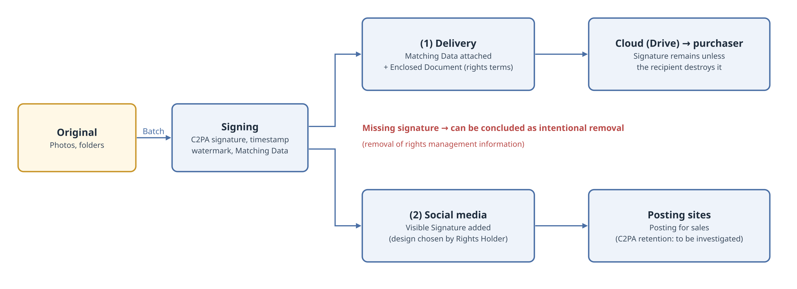
Figure 5 Processing streams
Item | (1) Delivery | (2) Social media
Purpose | Deliver images to purchasers through sales | Post to posting sites for the purpose of sales
Route | Delivered in folder batches by sharing through the cloud (Google Drive, etc.) | Posted to posting sites (Patreon, X, Weibo, etc.)
C2PA signature | Attached | Attached
Matching Data | Attached to every image | Attached
Visible Signature | Open (O-11) | Added (in a design chosen by the Rights Holder)
Enclosed Document | Enclosed (Chapter 9) | Not enclosed
Survival of the signature | Remains unless the recipient intentionally removes it | May be removed by the posting site (To Be Investigated)

7.3 Delivery Stream
Users deliver sold images directly to purchasers via the cloud. On this route, the signature attached to the image remains unless the recipient intentionally removes it.
Accordingly, if the signature is missing from a delivered image, it can be concluded that the recipient intentionally removed it. The act of removing a signature or watermark may in itself be unlawful as removal of rights management information [16][19][20][27].
If a sold image carries no C2PA signature, the person who purchased it can pose as the Rights Holder. At present, no arrangement concerning rights between Users and purchasers is written down anywhere. The System shall address this by attaching a C2PA signature and Matching Data to Delivery Images and indicating where the rights lie through Enclosed Documents (see Chapter 9).

7.4 Social Media Stream
Users post to social media in order to sell photographs. Social Media Images therefore require a Visible Signature indicating where the rights lie. On Social Media Images, it is acceptable for the Rights Holder’s name to be displayed visibly.
The content and design of the Visible Signature shall be chosen by the Rights Holder. Visible Signatures are created and applied through the image editing screen and batch application (see Chapter 8).
Whether posting sites retain or remove C2PA signatures upon upload cannot be known without investigation. It is quite conceivable that some sites remove them. In the social media stream, the System shall provide means of protecting rights through the Visible Signature and the invisible watermark, separately from the C2PA signature.

7.5 To Be Investigated
- Whether each posting site retains C2PA signatures upon upload (I-03)

7.6 Decisions in This Chapter
No. | Decision
D-7-1 | A C2PA signature is attached to every image output
D-7-2 | The three layers of Section 4 of the Draft Project Proposal (C2PA signature, invisible watermark, matching hashes) are carried over
D-7-3 | Two streams are provided: (1) delivery and (2) social media
D-7-4 | Matching Data is attached to Delivery Images, and Enclosed Documents are enclosed with them
D-7-5 | A Visible Signature in a design chosen by the Rights Holder is added to Social Media Images
D-7-6 | A missing signature is treated as something that can be concluded to be intentional removal by the recipient

Chapter 8 Screens and Usability

8.1 Appearance
The Client App shall have an appealing appearance. Cosplayers, who are the Users, like characters and cute things. Software that looks unappealing will not be used, however good its functions.
Appearance is treated as a requirement directly tied to the effectiveness of the System. If the System is not used by Users, neither signatures nor Notices are applied, and the deterrence set out in Section 2.2 does not work.

8.2 Screens
The Client App shall have the following screens.
Screen | Purpose | Main requirements
Image editing screen | Create Visible Signatures for Social Media Images | Names, dates, overlay images, and license statements can be created as templates in a design the Rights Holder likes, and applied
Batch application | Process by folder | A template can be applied to the images in a folder in a batch. Placement, orientation, and color can be adjusted for each photograph
Rights Document creation screen | Select the Permitted Scope and create Enclosed Documents | How far rights are granted for the images sold can be selected by an easy-to-understand method such as radio buttons

How Registration (Chapter 10), status checking (Chapter 10), guidance on legal action (Chapter 11), and other functions are organized into screens shall be decided in the design document. The details of each screen shall also be decided in the design document.

8.3 Reconciling Editing and Batch Application
A screen for editing images one at a time and a function for applying in batches by folder appear at first to be conflicting requirements. This document reconciles them by saving the design created on the editing screen as a template, which can then be applied either to single images or by folder.
As shown in the example in Section 3.3.1, Users adjust the position, orientation, and color of the Visible Signature for each photograph. Even in batch application, it shall be possible to adjust, for each photograph, placement that avoids the subject and color matched to the background.

8.4 Decisions in This Chapter
No. | Decision
D-8-1 | The Client App shall have an appealing appearance. Appearance is treated as a requirement directly tied to the effectiveness of the System
D-8-2 | The image editing screen, batch application, and the Rights Document creation screen are provided. The organization of other screens is decided in the design document
D-8-3 | A design created on the editing screen becomes a template that can be applied to single images or by folder
D-8-4 | Even in batch application, placement, orientation, and color can be adjusted for each photograph
D-8-5 | The details of the screens are decided in the design document

Chapter 9 Rights Documents and Languages

9.1 Selection of the Permitted Scope
There are different kinds of rights. The Rights Holder shall choose, at the time of sale, how far rights are granted to purchasers for the images sold. The choice is made on the Rights Document creation screen by an easy-to-understand method such as radio buttons (see Chapter 8).
The kinds of rights offered as options shall be decided in the design document.
The Permitted Scope chosen at the time of sale becomes the criterion for judging “what is infringed” by a repost when it is later registered (see Chapter 10).

9.2 Enclosed Documents
Images uploaded to the cloud by folder for sale shall be accompanied by an Enclosed Document stating the following.
- Provisions concerning rights (including that rights do not transfer by purchase)
- The Permitted Scope
- A sentence stating that the images must not be passed to others without permission
- What means the Rights Holder may take if the Matching Data is erased and the images are used outside the Permitted Scope
- What acts may give rise to what liability
The Enclosed Document also serves to help those whose understanding of rights is insufficient. It is thought that most purchasers do not believe that purchasing an image gives them its rights as well. The Enclosed Document is treated not as a strongly worded contract but as a statement of facts. Even where there is concern that writing an Enclosed Document may reduce sales, it shall be sufficient for the context of rights to be shown in the delivered directory.
If the sentence in the Enclosed Document stating that the images “must not be passed to others without permission” is lost in the course of passing them on, this is not due to the fault of the Rights Holder.

9.3 Countries Covered
The content of Rights Documents differs not by language but by country (jurisdiction). Even within the English-speaking world, the laws of the United States, the United Kingdom, Canada, and Australia differ. Therefore, “English” does not work as a category for Rights Documents.
This document sets out the countries covered by Rights Documents as follows.
- Information covering all countries is published as a link destination.
- Text versions are enclosed only for the nationalities common among purchasers.
- The text is not varied by selecting the purchaser’s country.
The nationalities common among purchasers are assumed to be known by the Rights Holder personally. How far the purchaser’s country can be known on sales platforms such as Patreon will be confirmed by NRSD through actual use (I-07).

9.4 Party Pursued
The party pursued under the System is the Infringer who published images and caused damage to the Rights Holder. Whether that person is a purchaser does not matter.
Pursuing the person who purchased an image directly is not realistic, because images can also be copied and passed on by USB and other means. If the Infringer is pursued as such, there is no need to identify purchasers, and the Rights Holder’s effort in selling does not increase.
When a repost occurs, the location of the repost site’s server is taken to be ascertainable by investigation. If it cannot be ascertained even by investigation, action on that repost shall be abandoned.

9.5 Approach to Governing Law (Reference)
In drafting the wording of Rights Documents, the following approach is used as a reference. The following is not legal advice, and confirmation by an expert is required before the wording is finalized.
Layer | Content | Approach to governing law
Permitted Scope (contract) | What is permitted | It is common for the parties to choose the governing law, and stating the seller’s country as the governing law can be considered. The content of the Permitted Scope itself can be written in a way that does not depend on the country
Infringement (use outside the Permitted Scope) | What liability arises | Governed by the laws of the country where protection is claimed (Berne Convention, Article 5(2) [28]). Because where infringement will occur is not known in advance, the country cannot be fixed in advance

The Berne Convention provides that the enjoyment and exercise of copyright in the countries of the Union shall not be subject to any formality [28]. In addition, Article 12 of the WIPO Copyright Treaty obliges Contracting Parties to provide legal remedies against, among other acts, removing or altering rights management information without authority [27]. The Chinese, US, and Japanese provisions cited in Section 2 of the Draft Project Proposal [16][19][20] all correspond to this.

9.6 Example of Application
The approach of this chapter is checked with the following example.
- A cosplayer living in Canada sold images through a US company’s platform (Patreon, etc.) and delivered them via Google Drive.
- The purchaser lived in China.
- The purchaser built a site on a server in China without permission and made the images downloadable by an unspecified number of people.
In this example, the infringement arises from publication on a server in China. Under the approach of this document, this infringement is pursued under Chinese law. Canada and China are both countries of the Berne Union, and works of Canadian authors are also protected in China. The fact that the sales platform belongs to a US company, and that Google Drive was used for delivery, does not determine the law applicable to the infringement.
Matters that may be pursued include copyright infringement (unauthorized publication and distribution), removal of rights management information if the Matching Data was removed [16], and the portrait rights of the subject [17]. Possible steps include identifying the operator by the method in Section 7 of the Draft Project Proposal (ICP registration number [22], etc.), notifying for removal, and filing suit in court where necessary. Work registration [21] may reinforce evidence showing ownership of the rights.
In this example, the contract (Permitted Scope) is considered to function mainly as material that rejects the claim that “having purchased it, I thought I could use it” and shows intent.
These article numbers and procedures are based on the references of the Draft Project Proposal and NRSD’s own research, and confirmation by an expert is required before the wording is finalized.

9.7 Display Languages
The display languages of the Client App shall be Japanese, Chinese, and English. If other languages are requested, they shall be added later.

9.8 Decisions in This Chapter
No. | Decision
D-9-1 | The Rights Holder chooses, at the time of sale, how far rights are granted
D-9-2 | The Permitted Scope chosen at the time of sale is the criterion for judging what a repost infringes
D-9-3 | Delivery Images are accompanied by an Enclosed Document stating the matters in Section 9.2
D-9-4 | The Enclosed Document includes a sentence stating that the images must not be passed to others without permission. Its loss is not due to the fault of the Rights Holder
D-9-5 | Information covering all countries is published as a link destination, and text versions are enclosed only for the nationalities common among purchasers
D-9-6 | The party pursued is the Infringer, regardless of whether it is a purchaser
D-9-7 | The location of the server is taken to be ascertainable by investigation; if it cannot be ascertained, action is abandoned
D-9-8 | The display languages are Japanese, Chinese, and English, with others added on request

Chapter 10 Registration of Reposts, Evidence Preservation, and Status Checking

10.1 Positioning
The function by which Users themselves find and register reposts is included within the scope of this document (the application of licenses). If a User who finds their own photographs published without permission cannot assert their rights on the spot, attaching signatures would be meaningless and the System would be of no use.
This function lies on a different axis from automated detection, in which a machine crawls the network and detects reposts (Chapter 13). Registration is an act by which the User personally applies the license.

10.2 Registration Flow
Figure 6 shows the registration flow.
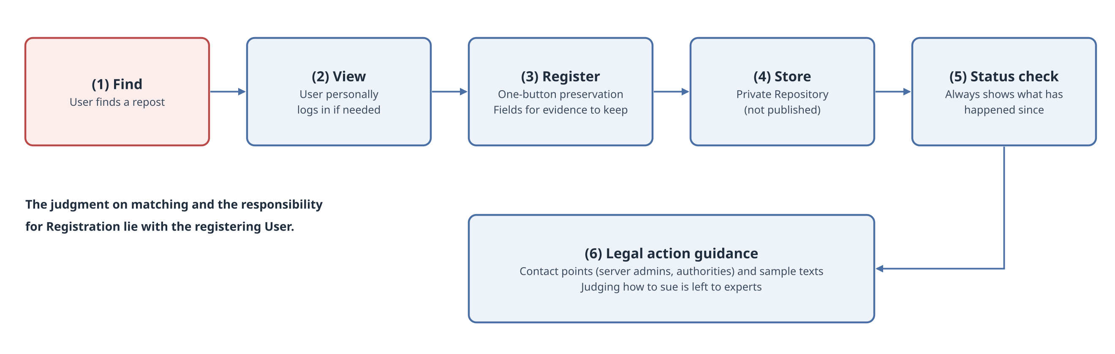
Figure 6 Flow of Registration and Evidence Preservation
- The User finds a repost.
- If the page requires login, the User personally logs in and views it. The Client App is not required to retrieve pages that require login.
- The User registers it from the Client App with a single button. Evidence is preserved at the same time as Registration. The User does not need to know what is needed as evidence.
- The registration screen has input fields indicating that “it is advisable to keep this kind of evidence as well.” How much evidence to keep is left to the User personally.
- Preserved evidence is stored in the Private Repository.
- The User can always see, from the Client App, what has since happened to registered reposts. The User is not required to look at GitHub.
- When taking action, the User follows the guidance on legal action (Chapter 11).

10.3 Matters to Be Shown Later
Evidence Preservation means leaving, at the time of discovery, a state in which what was happening at that time can be shown when rights are asserted later. The matters to be shown later are the following five.
No. | Matter to be shown | What is kept | When it is kept
(1) | That it is one’s own work | C2PA signature, trusted timestamp, Original | At signing (already exists)
(2) | When and where it was published | Record of the repost page and its trusted timestamp | At Registration
(3) | That it is the same image | Result of matching by watermark and matching hashes | At Registration
(4) | Who published it, and where | Information on the server and operator | At Registration
(5) | That it is use outside the Permitted Scope | The Permitted Scope chosen at sale, the Enclosed Document, and the Notice | At sale and at Notice (already exists)

Items (1) and (5) are already at hand from earlier work. Items (2) to (4) cannot be obtained afterward once the repost page is deleted, and must therefore be kept at the time of discovery.
What specifically is to be obtained (screen records, times, addresses, what was missing for each medium, etc.) shall be decided in the design document.
Section 7 of the Draft Project Proposal provides for trusted timestamps as follows. This document carries this over.
Trusted timestamp: Because git commit dates are self-declared and have no probative value, an RFC 3161 [8] timestamp is obtained for the hash of each saved page, and its certificate is saved together with it.
（Draft Project Proposal, Section 7）
The country-specific reinforcement of evidence cited in Section 7 of the Draft Project Proposal (electronic evidence recorded on blockchains at Internet Courts in China [18]; notarial deeds or evidence-grade recording services in Japan) and the identification of operators (ICP registration number [22]; WHOIS and ASN lookups [23]) shall be referred to when the design document sets the approach for Evidence Preservation and guidance on legal action.

10.4 Responsibility
After recompression or cropping, matching results are no more than probabilistic. However, Registration is performed by a human User. The judgment on matching and the responsibility for Registration shall be borne by the User who registered.

10.5 Where Evidence Is Stored
Preserved evidence shall be stored in the Private Repository and not published. If evidence is published and the User makes an erroneous Registration or other mistake, the User may in turn be sued.
Evidence of repost pages is a copy of information published on the network. No grounds are found for regarding its storage for the purpose of asserting rights as a collection of serious personal information. On the other hand, sales history and sales contracts (purchaser information) are not handled by the System (Section 2.4).

10.6 Sharing the Burden
It is an unreasonable burden for the person who found a repost to follow it alone to its final outcome. The System holds data in the Private Repository in order to relieve part of this burden. The idea of automated detection (Chapter 13) comes from the same place.
Repost sites often carry photographs of many Rights Holders, not just one. If other Users can refer to information on repost sites registered by one User, other Rights Holders can more easily find their own photographs. Confirming whether a work is one’s own and registering it are done by each User, and, as in Section 10.4, the responsibility is borne by the User who registered. The scope and method of sharing shall be decided in the design document.

10.7 Decisions in This Chapter
No. | Decision
D-10-1 | Registration of reposts by Users themselves is included within the scope of this document
D-10-2 | Registration is done from the Client App with a single button, and evidence is preserved at the same time
D-10-3 | Pages requiring login are obtained by the User personally logging in
D-10-4 | Input fields indicating evidence that should be kept are provided
D-10-5 | The specific items to be obtained are decided in the design document
D-10-6 | The judgment on matching and the responsibility for Registration are borne by the User who registered
D-10-7 | Evidence is stored in the Private Repository and not published
D-10-8 | The status of registered reposts can always be seen without looking at GitHub
D-10-9 | Information on registered repost sites can be referred to among Users; the scope and method are decided in the design document

Chapter 11 Scope of Support for Legal Action

11.1 Scope of Support
The System is not a substitute for legal experts and does not judge how rights infringement should be pursued. Section 9 of the Draft Project Proposal, after providing that NRSD’s legal counsel will handle lawsuits concerning the operation of the System, states as follows. This document carries this over.
However, this does not serve to protect users’ rights. Takedown requests and damage claims against unauthorized reposting must be pursued by each user as the Rights Holder.
（Draft Project Proposal, Section 9）
On the other hand, it is possible to present contact points. The System shall present the following guidance to Users who have registered reposts. These are general matters whose correctness can be checked by research.
- Complaint contact points (infringement complaint channels of posting sites, authorities in charge of information, server administrators, etc.)
- Sample texts to send to contact points (sample emails to server administrators, etc.)
- References to the laws of each country
Section 8 of the Draft Project Proposal lists where to file as follows. This document carries this over.
Where to file: Infringement complaint channels of Weibo, Xiaohongshu, Bilibili, and others; DMCA notices to US service providers; and notices to server providers and operators.
（Draft Project Proposal, Section 8）

11.2 References to the Laws of Each Country
The laws of each country shall be accumulated as reference information within a framework covering “all” countries. Because assembling everything at once is not realistic, they shall be added comprehensively as implementation progresses.

11.3 Approach to Deterrence
A means of action has no meaning unless it can actually be used. However, having the means ready, together with the intent to take action when appropriate, is in itself a deterrent. The greatest value of the System lies in this deterrence (Section 2.2).
If an actual action does not succeed, it shall be treated as an issue, carried forward, and referred to experts.

11.4 Decisions in This Chapter
No. | Decision
D-11-1 | How to pursue infringement is not judged
D-11-2 | Contact points, sample texts, and references to the laws of each country are presented as guidance
D-11-3 | The laws of each country are accumulated as references within an “all countries” framework and added with each implementation

Chapter 12 Repository Management, Distribution, and Updates

12.1 Repository Structure
The System provides the following two repositories. Figure 7 shows the structure.
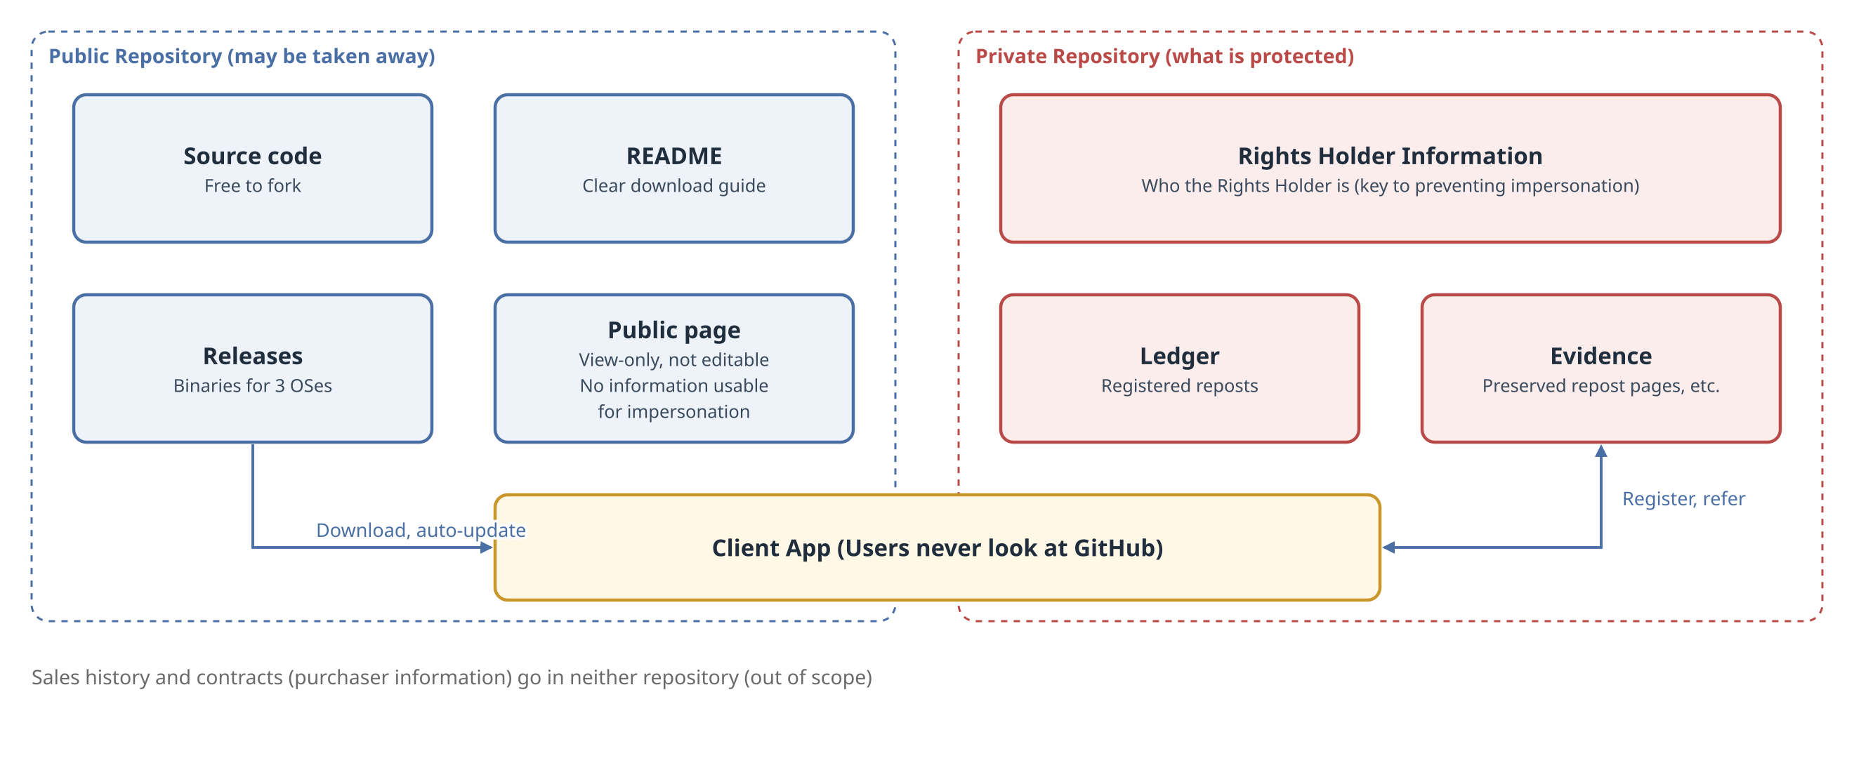
Figure 7 Repository structure
Repository | What it holds | Published
Public Repository | Source code, binaries (releases), the README, and the public page | Published. May be taken away
Private Repository | Rights Holder Information (who the Rights Holder is), the ledger, and evidence of reposts | Not published

Only the information to be kept non-public is split off into a separate repository and made private. There is no problem with the software of the System itself being taken away. What must be protected is the rights of the Rights Holders set out in Section 2.1, and what must be closed for that purpose is Rights Holder Information and writing to the ledger and evidence.
Under GitHub’s specifications, the setting to allow or prevent forking is provided for private repositories owned by organizations [29]. Forking of a public repository cannot be prevented, but in the structure of this document there is no need to prevent the Public Repository from being forked.

12.2 Public Page
Viewing of the public page shall not be prevented. The public page shall not be editable, and information that could be used for impersonation shall not be posted on it. The content to be posted on the public page shall be decided in the design document.

12.3 Relationship with Fork Operation in the Draft Project Proposal
Section 9 of the Draft Project Proposal provides that those wishing to use the tools fork them and operate them at their own responsibility.
The tools will be published on GitHub, and those wishing to use them shall fork them and operate their own copies at their own responsibility. NRSD bears no responsibility for the results of the operation of any fork.
（Draft Project Proposal, Section 9）
This document requires that Users are not engineers and can use the System without looking at GitHub (Chapter 3). Therefore, it is not presupposed that Users themselves fork and operate the System. Forking is done by those who intend to modify the System, and NRSD shall bear no responsibility for the results of the operation of any fork.
Section 1 of the Draft Project Proposal provides that the tools will be released free of charge “within the scope defined by their license.” The scope of publication is defined by the license, and publishing the software is compatible with closing the information to be protected in the Private Repository.

12.4 Distribution
Users shall download the Client App from a GitHub link. By writing the README on the top page of the Public Repository in an easy-to-understand way, even Users who do not understand GitHub shall be able to download it.

12.5 Updates
The Client App shall incorporate a mechanism that receives updated binaries from the Public Repository and updates itself. Users shall not need to perform any operation for updates.

12.6 To Be Investigated
- Whether GitHub (including the public page) can be reached from mainland China (I-04)
- Code signing on macOS and Windows (OS warnings when unsigned, and cost) (I-05)

12.7 Decisions in This Chapter
No. | Decision
D-12-1 | Two repositories are provided: the Public Repository and the Private Repository
D-12-2 | The software is published, and its being taken away is not prevented
D-12-3 | Rights Holder Information, the ledger, and evidence are placed in the Private Repository
D-12-4 | The public page is viewable and not editable, and information that could be used for impersonation is not posted on it
D-12-5 | Fork operation by Users themselves is not presupposed
D-12-6 | Distribution is from a GitHub link, with an easy-to-understand README
D-12-7 | The Client App receives binaries from the Public Repository and updates itself

Chapter 13 Treatment of Phase 2
Section 12 of the Draft Project Proposal provides, as Phase 2, for an autonomous application that crawls the network and automatically detects reposted images and the sites hosting them.
This document treats Phase 2 as a design plan separate from this document. This document deals with the application of licenses, and Phase 2 deals with the detection of license violations, because the two lie on different axes.
The design plan for Phase 2 presupposes the results of Phase 1 based on this document. Since reposts detected in Phase 2 are expected to be registered in the Registration mechanism of Chapter 10, the Registration mechanism shall be designed so as to leave room to accept Registration from automated detection later.
The items for consideration cited in Section 12 of the Draft Project Proposal (handling of social networks requiring login and sites with strong anti-scraping measures, relationship with each site’s terms of service, and crawling load and cost) shall be dealt with in the design plan for Phase 2.
No. | Decision
D-13-1 | Phase 2 shall be a separate design plan
D-13-2 | The Registration mechanism shall be designed so as to leave room to accept Registration from automated detection later

Chapter 14 Matters To Be Investigated
The following matters shall be investigated at the design document stage, and the means of realization shall be set according to the results.
No. | Matter | Related chapter | Content of investigation | Affects
I-01 | C2PA signing certificates | Chapter 5 | Whether they can be issued to individuals, the method of identity verification, support for the C2PA Trust List, and cost | Approach to confirming identity; display on existing public verification sites
I-02 | Matching between Notice accounts and signing keys | Chapter 5 | Whether the signing key fingerprint or similar can be posted on each posting site’s profile and matched | Approach to confirming entitlement
I-03 | Retention of C2PA signatures on posting sites | Chapter 7 | Whether each posting site retains or removes C2PA signatures upon upload | Means of protection in the social media stream
I-04 | Access to GitHub from mainland China | Chapter 12 | Whether distribution, updates, and Registration to the Private Repository are possible from mainland China | Routes for distribution, updates, and Registration
I-05 | Code signing | Chapter 12 | The content of OS warnings for unsigned applications on macOS and Windows, and the cost of signing | Form and cost of distribution
I-06 | Differences in rights by country | Chapters 9, 11 | Differences among countries in the protection of copyright, portrait rights, and rights management information | Enclosed Documents, references, and guidance on legal action
I-07 | Knowing the purchaser’s country | Chapter 9 | How far the purchaser’s country can be known on Patreon and similar platforms (confirmed by NRSD through actual use) | Nationalities of the enclosed texts
I-08 | Wording of Rights Documents | Chapter 9 | Confirmation by an expert of the wording of Rights Documents and Enclosed Documents | Enclosed Documents

Chapter 15 Open Matters
The following matters are those whose conclusion is reserved at the stage of this document, or candidates whose adoption has not been decided.
No. | Matter | Related chapter | Current status
O-01 | Approach to confirming identity and entitlement | Chapter 5 | Candidates are a certificate issued after identity verification by a certificate authority, and matching against Notice accounts. To be decided in the design document according to the results of I-01 and I-02
O-02 | Development base | Chapter 6 | A configuration using Tauri is a candidate. To be decided in the design document
O-03 | Approach to governing law | Chapter 9 | The approach of separating the Permitted Scope (contract) from infringement is used as a reference. To be decided according to the results of I-06 and I-08
O-04 | Options for the Permitted Scope | Chapter 9 | The options to be offered as kinds of rights are to be decided in the design document
O-05 | Content of the public page | Chapter 12 | Only that it is viewable, not editable, and carries no information usable for impersonation has been set. The content is to be decided in the design document
O-06 | Sharing of information on repost sites | Chapter 10 | The scope and method of sharing are to be decided in the design document
O-07 | OS-specific integration | Chapter 6 | Whether to provide right-click menus and similar is to be decided in the design document
O-08 | Issuer of identification numbers | Chapter 7 | Section 9 of the Draft Project Proposal cites “the GUI for obtaining identification numbers,” but the issuing entity has not been set. To be decided in the design document
O-09 | NRSD’s license type | Chapter 17 | The Draft Project Proposal states that “the license type is not specified at this time.” To be decided before release
O-10 | Recording location of work data | Chapter 7 | Where identification numbers and matching hashes are recorded is to be decided in the design document
O-11 | Visible Signatures on Delivery Images | Chapter 7 | Whether to add a Visible Signature to Delivery Images is to be decided

Chapter 16 Comparison with the Draft Project Proposal
How each section of the Draft Project Proposal is treated in this document is shown below. “Carried over” means the statement of the Draft Project Proposal is inherited; “Changed” means it is revised by this document; “Separated” means it is moved to a separate design plan.
Draft Project Proposal | Summary of statement | Treatment | This document
Opening | Ownership of copyright; license type not specified | Carried over | Cover, Chapter 15 (O-09)
Section 1 | Background and purpose | Carried over (what is protected is made concrete) | Section 2.1
Section 2 | Basic policy (detection, proof, deterrence) | Carried over (deterrence is the greatest value) | Section 2.2
Section 3 | Notice on each posting site | Carried over (a candidate for use in matching entitlement) | Sections 4.3, 5.3
Section 4 | Three layers of information, identification numbers, process flow | Carried over (two streams added) | Chapter 7
Section 5 | User tasks | Changed (sales, Visible Signatures, and creation of Rights Documents added) | Section 4.3
Section 6 | Signing tool (Windows right-click menu) | Changed (extended to three operating systems) | Section 6.1
Section 6 | Implemented on the basis of c2pa-python | Changed (not fixed) | Section 6.2
Section 6 | Accumulating repost pages and images on the public page | Changed (evidence placed in the Private Repository) | Section 10.5, Chapter 12
Section 6 | Registration of reports limited to the signer | Changed (limitation to Users (the Rights Holders and those authorized by them) made a requirement, treated as [Design Required]) | Chapter 5
Section 7 | Reporting reposts and preserving evidence | Carried over (storage made private; items to obtain deferred to the design document) | Chapter 10
Section 8 | Declaration of rights and legal action | Carried over (support limited to guidance) | Chapters 9, 11
Section 9 | Operation by each party through forks | Changed (fork operation by Users not presupposed) | Section 12.3
Section 9 | Handling of lawsuits concerning the operation of the System by legal counsel | Carried over (separate from action against infringement of Users’ rights; not changed by this document) | Section 11.1
Section 10 | Limitations and notes | Carried over | Section 2.5
Section 11 | Implementation items | Changed (image editing screen, Rights Document creation screen, automatic updates, etc. added) | Chapters 8, 12
Section 11 | Automatic drafting of complaint texts | Changed (made sample texts within the guidance on legal action) | Chapter 11
Section 12 | Phase 2: automated detection application | Separated | Chapter 13
Section 13 | Document structure | Carried over | Section 1.2
Section 14 | Third-party rights and licenses | Carried over (latest terms confirmed) | Chapter 17
Section 15 | References | Carried over (additions) | Chapter 18

The implementation items in Section 11 of the Draft Project Proposal, as revised by the decisions of this document, are as follows.
Implementation item | Treatment
Signing tool: batch processing of C2PA signatures, trusted timestamps, watermarks, and identification numbers, and the GUI | Carried over (supporting three operating systems)
Right-click menu integration (Windows) | Deferred to the design document (O-07)
Reporting tool: URL registration, page saving, trusted timestamps, and matching | Carried over (as Registration, Evidence Preservation, and status checking)
Public page: deployment to GitHub Pages and accumulation of report data | Changed (public page view-only; evidence placed in the Private Repository)
Sample notice texts (English and Chinese) | Carried over
Automatic drafting of complaint texts | Changed (sample texts within the guidance)
Publication on GitHub and notification to AYA | Carried over (including distribution via the README)
Image editing screen, batch application | Added
Rights Document creation screen and Enclosed Documents | Added
Authentication of Users | Added (including [Design Required])
Self-update | Added
Guidance on legal action and references to the laws of each country | Added

Chapter 17 Third-Party Rights and Licenses
Section 14 of the Draft Project Proposal provides as follows concerning the terms of use of third-party components.
Because the terms of use of third-party components may change, the latest terms shall be confirmed in the design plan.
（Draft Project Proposal, Section 14）
Accordingly, the results confirmed on September 29, 2026 are shown below. Rights in the standards, algorithms, and software considered for adoption in this document belong to their respective rights holders.
Component | Rights holder | License / terms of use | Result of confirmation | Ref.
C2PA Technical Specification | C2PA (Coalition for Content Provenance and Authenticity) | Terms of use set by C2PA | Latest version is 2.4 (the Draft Project Proposal refers to 2.2) | [1]
c2pa-python | Content Authenticity Initiative | MIT License and Apache License 2.0 | No change. A component for using c2pa-rs from Python | [14]
TrustMark | Adobe | MIT License | No change. Implementations exist in Python, JavaScript, and Rust | [9][10]
PDQ | Meta Platforms | BSD License (ThreatExchange repository) | No change | [12][25]
RFC 3161, 5280, 8949, 9052 | IETF Trust | Terms of use set by the IETF | — | [3][4][5][8]
ISO/IEC 19566-5 (JUMBF) | ISO, IEC | Terms of use set by ISO and IEC | — | [6]
Tauri (candidate) | Tauri Apps Contributors (The Tauri Programme in the Commons Conservancy) | MIT License or Apache License 2.0 | Adoption to be decided in the design document (O-02) | [26]

Upon release, the license terms and copyright notices of each component shall be bundled with the software, and their compatibility with the license set by NRSD shall be confirmed. If components are added through the selection of the development base (O-02), they shall be added to this table in the design document.

Chapter 18 References
The numbers in brackets in the text correspond to the following references. References [1] to [23] are carried over from Section 15 of the Draft Project Proposal, and [24] onward were added in this document.

Provenance and digital signatures
[1] C2PA, Content Credentials: C2PA Technical Specification, Version 2.2. https://spec.c2pa.org/specifications/specifications/2.2/specs/C2PA_Specification.html (Related: Chapters 7, 17. The latest version as of September 29, 2026 is 2.4)
[2] C2PA Technical Working Group, C2PA Content Credentials Explained: Addressing Common Questions and Updates, September 2025. https://c2pa.org/wp-content/uploads/sites/33/2025/10/content_credentials_wp_0925.pdf (Related: Chapter 7)
[3] IETF RFC 5280, Internet X.509 Public Key Infrastructure Certificate and CRL Profile. https://www.rfc-editor.org/rfc/rfc5280 (Related: Chapters 7, 17)
[4] IETF RFC 9052, CBOR Object Signing and Encryption (COSE): Structures and Process. https://www.rfc-editor.org/rfc/rfc9052 (Related: Chapters 7, 17)
[5] IETF RFC 8949, Concise Binary Object Representation (CBOR). https://www.rfc-editor.org/rfc/rfc8949 (Related: Chapter 17)
[6] ISO/IEC 19566-5, JPEG Systems — Part 5: JPEG Universal Metadata Box Format (JUMBF). (Related: Chapter 17)
[7] NIST FIPS 180-4, Secure Hash Standard (SHS). https://nvlpubs.nist.gov/nistpubs/FIPS/NIST.FIPS.180-4.pdf (Related: Chapter 10)

Trusted timestamps
[8] IETF RFC 3161, Internet X.509 Public Key Infrastructure Time-Stamp Protocol (TSP). https://www.rfc-editor.org/rfc/rfc3161 (Related: Chapters 7, 10, 17)

Invisible watermarking
[9] T. Bui, S. Agarwal, J. Collomosse, TrustMark: Universal Watermarking for Arbitrary Resolution Images, arXiv:2311.18297. https://arxiv.org/abs/2311.18297 (Related: Chapters 7, 17)
[10] Adobe, TrustMark official implementation (MIT License). https://github.com/adobe/trustmark (Related: Chapters 6, 7, 17)
[11] Content Authenticity Initiative, TrustMark FAQ (status as a C2PA-approved watermarking method). https://opensource.contentauthenticity.org/docs/trustmark/FAQ (Related: Chapter 7)

Matching by perceptual hashing
[12] Meta, The TMK+PDQF Video-Hashing Algorithm and the PDQ Image Similarity Algorithm (hashing.pdf). https://github.com/facebook/ThreatExchange/blob/main/hashing/hashing.pdf (Related: Chapters 6, 7, 17)
[13] PDQ & TMK+PDQF – A Test Drive of Facebook’s Perceptual Hashing Algorithms, arXiv:1912.07745. https://arxiv.org/abs/1912.07745 (Related: Chapter 7)

Implementation and verification
[14] Content Authenticity Initiative, c2pa-python. https://github.com/contentauth/c2pa-python (Related: Chapters 6, 17)
[15] Content Authenticity Initiative, Content Credentials verification site. https://verify.contentauthenticity.org (Related: Chapters 3, 7)

Laws and systems
[16] Copyright Law of the People’s Republic of China (2020 Amendment), Art. 12 (work registration), Art. 51 (rights management information), Art. 54 (damages). WIPO Lex: https://www.wipo.int/wipolex/zh/legislation/details/21065 (Related: Chapters 7, 9)
[17] Civil Code of the People’s Republic of China, Arts. 1018 and 1019 (portrait rights). (Related: Chapter 9)
[18] Provisions of the Supreme People’s Court on Several Issues Concerning the Trial of Cases by Internet Courts (Fa Shi [2018] No. 16), Art. 11. https://www.court.gov.cn/fabu/xiangqing/116981.html (Related: Chapter 10)
[19] 17 U.S.C. §1202 (integrity of copyright management information), §1203 (civil remedies). https://www.law.cornell.edu/uscode/text/17/1202 , https://www.law.cornell.edu/uscode/text/17/1203 (Related: Chapters 7, 9)
[20] Copyright Act of Japan (Act No. 48 of 1970), Art. 2(1)(xxi) (rights management information), Art. 113 (acts deemed infringement). https://laws.e-gov.go.jp/law/345AC0000000048 (Related: Chapters 7, 9)
[21] Copyright Protection Center of China (work registration). https://www.ccopyright.com.cn (Related: Chapter 9)
[22] MIIT ICP/IP Address/Domain Name Filing Management System. https://beian.miit.gov.cn (Related: Chapters 9, 10)
[23] ICANN Lookup (RDAP/WHOIS). https://lookup.icann.org (Related: Chapter 10)

References added in this document
[24] C2PA, Conformance Program and C2PA Trust List. https://c2pa.org/conformance/ (Related: Chapter 5)
[25] Meta, ThreatExchange LICENSE (BSD License). https://github.com/facebook/ThreatExchange/blob/main/LICENSE (Related: Chapters 6, 17)
[26] Tauri. https://github.com/tauri-apps/tauri (Related: Chapters 6, 17)
[27] WIPO Copyright Treaty, Article 12 (Obligations concerning Rights Management Information). https://www.wipo.int/wipolex/en/text/295166 (Related: Chapters 7, 9)
[28] Berne Convention for the Protection of Literary and Artistic Works, Article 5. https://www.wipo.int/wipolex/en/text/283698 (Related: Chapter 9)
[29] GitHub Docs, Managing the forking policy for your repository. https://docs.github.com/en/repositories/managing-your-repositorys-settings-and-features/managing-repository-settings/managing-the-forking-policy-for-your-repository (Related: Chapter 12)

